2019 WAMPANOAG PADDLERS TRIP SCHEDULE

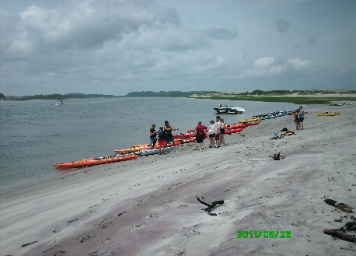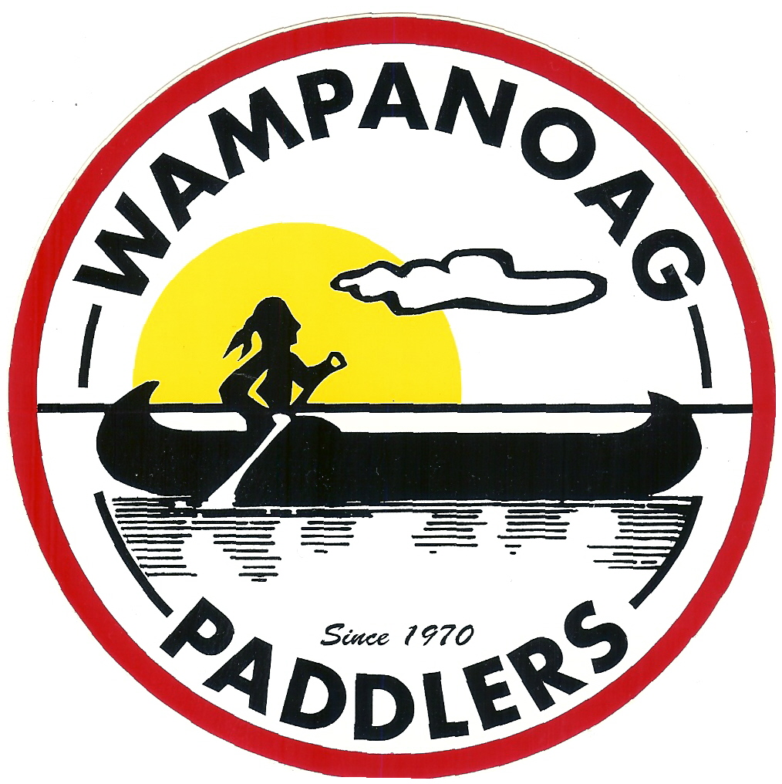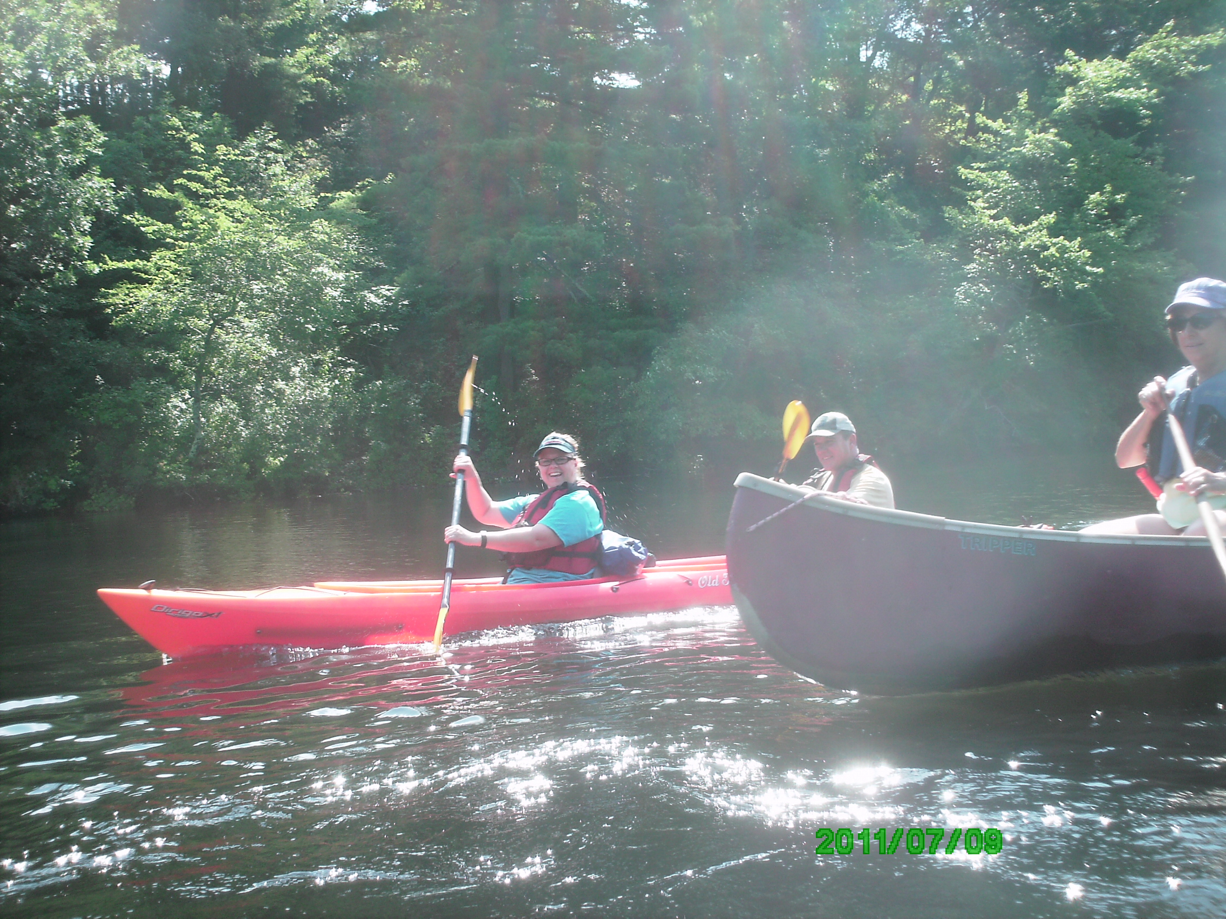

The Wampanoag Paddlers can be found online at
https://www.wampy-paddlers.org
https://groups.yahoo.com/neo/groups/Wampypaddlers
https://www.facebook.com/groups/wampypaddlers

Paddlers MUST contact the trip leader before a trip to be notified in case of changes or cancellation.

Date | River & Description | Trip Leader/Contact
May 19  Saturday | Charles River (F)  Medfield Jct to Farm Road in Dover with a lunch stop at Rocky Narrows. | Tom Lane  781-762-2220
May 25-28  Fri - Mon | Wompatuck Camping (Memorial Day)  Wompatuck State Park, Hingham MA  On Line Reservations: http://www.reserveamerica.com  Try for “E” Road area  Events may include a pot luck BBQ, biking or hiking, and flatwater paddling on the Reservoir, Back River Hingham, or Hingham Harbor | George Estano 781-248-9876
May 24 - 28  (Fri – Tues) | Pemigawasset River (F, Q, 1) and camping (Memorial Day)  Camping at Pemi River campground, Thornton NH (603) 726-7015. Talk to Jerry. | Rob Gallerane  508-340-7967
June 1 - 4  Fri - Mon | Battenkill River, Arlington, VT (F, Q, 1) and camping  “Camping on the Battenkill" in Arlington, VT (800) 830-6663) Call early for reservation. http://www.campingonthebattenkillvt.com  The Battenkill provides two days of beautiful paddling in southern Vermont plus lots to see in and do in the area. It is a fast, rocky cold-water stream. We'll start the first day directly from the campground in Arlington and canoe down across the border into New York taking out at a covered bridge. Sunday we'll shuttle the cars down to Rt. 22 and start back at the covered bridge. | Joe Packard  508-478-8500  Or  Rob Gallerane  508-340-7967
June 10  Sunday | Sudbury River (F)  This is a flatwater, quiet trip with lots of scenery and quiet paddling. At 7.2 miles it should work out to about 3-4 hours of paddling and some additional time for a lunch stop. Should time allow, we can paddle 600 feet past the take out and view the Old Rude (North) Bridge at the Concord Battle Ground where a few (soon to be) Americans said: "No!" to the British.  Bring a picnic Lunch, appropriate weather gear, a story to tell and pray for a tail wind.  PUT IN: Sherman Bridge on Sudbury Bridge Road, Wayland. It changes names to Lincoln Rd. at the bridge where it enters Sudbury. There is parking for cars here and at the take out. Shove off time (AIS) will be 10:00AM. Not to be confused with 10:15AM or any other such time.  TAKE OUT: Lowell Rd Boat ramp, Concord.  Your trip leader will be Jich Estano. Please call to let me know you are joining the trip. If there is a schedule or plan change I promise I will let you know. If you don't call, I will change the schedule just to mess with you. There will be a prize for the best call.  the Jich. | George Estano  781-248-9876
June 29–July 5  (Fri – Thurs) | Wompatuck Camping (July 4th weekend)  Wompatuck State Park, Hingham MA  On Line Reservations: http://www.reserveamerica.com  Try for “E” Road area.  Events may include a pot luck BBQ, biking or hiking, and flatwater paddling on the Reservoir, Back River Hingham, or Hingham Harbor. | Maureen Lane Krinitt  671-697-1969
June 29–July 8  (Fri – Sun) | Umbagog State Park, Errol NH (F, Q, camping, hiking)  Reserve campsite in the park at http://www.reserveamerica.com  Flat water paddling on Lake Umbagog, fast water on the Androscoggin River. Hiking in the state park. | Rob Gallerane  508-340-7967
Aug 17 – 20  (Fri – Mon) | Jaffrey Fireworks and Contoocook River (F)  Camping at Greenfield State Park; reserve at  http://www.reserveamerica.com  Fantastic Fireworks, Call Rob early for information on getting tickets for this not to be missed show. | Rob Gallerane  508-340-7967
Aug 24 – 26  (Fri – Sun) | Androscoggin River (Camping  Pleasant River Campground, Bethel Maine  Reservations: Pleasant River Campground 207-836-2000 (Mention Wampy trip)  This is a traditional stop over on the way to Cathedral Pines, Eustis, MA.  Events: Paddle a section of the Androscoggin River (day trip).  Group pot luck with Pie iron// Satellite// Flying saucer dinner. Bring pie irons if you own them. | Rob Gallerane  508-340-7967
Aug 26 –  Sept 11  (come for some or all of these dates) | Cathedral Pines Campground (Labor Day weekend)  Call early for reservations 207 246-3491. Mention that you are a Wampy when you call.  Events: There will be a repeat of the International Pot Luck Dinner. For information call Margaret Estano 781 248 9876. We may paddle on the Dead River, Lake Flagstaff, Chain of Lakes. Night paddle on the lake if there is a full moon. Bicycling on the train trail is likely, along with other special events. | Maureen Febiger  781 707-6379
Oct 4 – 9 | Wilgus State Park and Connecticut River (F, camping)  Camping at Wilgus State Park in Ascutney, Vt. Call early for  reservations: 1-800-674-542 or go to vtstateparks.com/wilgus  Great fall colors on a peaceful section of the river. Enjoy side-trips to yard sales or do some hiking. Church dinner Sat. night and potluck breakfast on Sunday morning. | Rob Gallerane  508-340-7967
Nov 17 2018 | End of Season Social  Meet and Greet at the Happy Hour at 5:30 pm  Potluck Dinner at 6:00pm with Yankee Swap to follow  WHERE: Home of Maureen and Chris Febiger  24 Crescent Street Wellesley, MA 02481  ( just off 128 between the Mass Pike and Route 9 ) | Maureen Febiger  781 707-6379
Jan or Feb 2019 | Annual Business Meeting & Preliminary Trip Planning  Date and Location TBD  Meet and Greet Happy Hour 5:30 p.m. Potluck Dinner 6:00 p.m. followed by business meeting | Maureen Febiger  781 707-6379

River Classification Guide

Trips are listed with the types of river conditions you can expect. The bold initial indicates the predominant class of water based on the International Scale of Difficulty as defined by the A.M.C.

Tidal (may be subject to open winds and currents may be strong)

P Portage | F Flatwater | Q Quick | 1=Class 1 rapids | 2=Class 2 rapids | 3=Class 3 rapids | 4=Class 4 rapids

If there is a trip that you would like to paddle as a leader, pick any date and email your float/shuttle plan to the membership at wampypaddlers@yahoogroups.com. Remember to include your contact information so that members who want to paddle with you can contact you for more details. If this is your first time leading a trip, and you would like to have an experienced leader co-lead the trip with you, please contact one of the officers.

For Trip Leaders Responsibilities and Trip Planning Guide please refer to: https://groups.yahoo.com/neo/groups/Wampypaddlers/files or see the Files section on our Facebook page.

Safety

  - PFD’s (life jackets) are required for all participants.
  - By law they must be worn Sept- May and at all times by children.
  - Canoes should have a spare paddle and a rope tied to both ends.
  - For spring and fall trips it is a good practice to bring extra clothes in a waterproof bag.
  - Phones, keys, matches & anything else that needs to be kept dry should also be in a waterproof bag tied into your boat.
  - There will be a lead boat for you to follow and a ‘sweep’ boat on all trips.
  - A whistle, attached to your PFD is a good way to signal the leader if there are any problems during the trip.

Contacts

If you need more information about the club or cannot reach a trip leader, please contact any of the officers:

President Maureen Febiger 781-707-6379 mhfebiger@gmail.com
Vice President Rob Gallerane 508-340-7967 rgallerane@yahoo.com
Secretary Cindy Neels 781-729-9712 neelsc77@gmail.com
Treasurer Margaret Estano 781-848-8686 memeestano@beld.net

